RAINBO

Raising the Digital Literacy of Professionals to Address Inequalities and Exclusion of LGBTQI Community

Intellectual Output 1: Needs assessment
Date: 10.11.2021
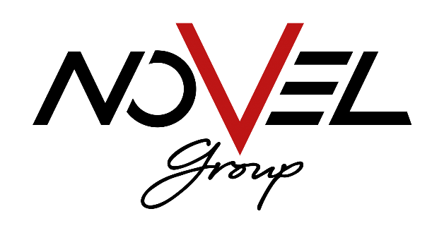

Document Identification:

Output title | Needs assessment
Output type | Research report
Lead Partner | Symplexis
Author(s) | Ester Maria Kalogeroudi
Contributor | -
Dissemination level | Confidential, only for members of the consortium
Status | Final
Version | 1
Date | 10/11/2021

The project has been funded with support from the European Commission.
The contents of this publication reflect only the author’s view and the Agency and the Commission are not responsible for any use that may be made of the information it contains.

Contents
National Report Template 3
Part A: Secondary/desk research results 4
Part B: Field/primary Research Results 11
Professionals 11
Receivers 15
Part C: General conclusions – comparative analysis between desk and field research findings 19
REFERENCES 22

National Report Template

General guidelines:
- Font: Calibri
- Font size: - 11
- Line space 1,5
- No spaces between paragraphs
- Footnotes at the end of the page
- APA Referencing Style
- Approximately 5000-8000 words
- Using the project’s template for deliverables

Part & Sections:

Part A: Secondary/desk research results

1. Challenges faced by LGBTQI people in the country, during the Covid-19 pandemic (approx. 700 words)
Data and statistics regarding discrimination on the grounds of sexual orientation, gender identity and/or sex characteristics - as well as other challenges and obstacles e.g. accessibility difficulties, lack of LGBTQI-focused services etc. that LGBTQI people (may) face - particularly in support services sector including psychosocial services, health services, career counselling services, educational/training services, information/referral services, provided by both the public and the private (including CSO organizations) sector, during the Covid-19 pandemic (or at least a year ago). ("A long way to go for LGBTI equality", 2021)

The information below summarizes the country data for Luxembourg in a nutshell. ("A long way to go for LGBTI equality", 2021) 40% avoid often or always holding hands with their same-sex partner in Luxembourg. For the EU-28, it is 61%. 19% in Luxembourg avoid often or always certain locations for fear of being assaulted. For the EU-28, it is 33%. 56% are now often or always open about being LGBT in Luxembourg. For the EU-28, it is 47%.
Regarding discrimination, 12% felt discriminated against at work in the year before the survey in Luxembourg. For the EU-28, it is 21%. Discrimination affects many areas of life, such as going to a café, restaurant, and hospital or to a shop. Overall, in Luxembourg in 2019 40% felt discriminated against in at least one area of life in the year before the survey. For the EU-28, it was 42%.
Regarding harassment and violence, 37% in Luxembourg say they were harassed the year before the survey. The EU-28 is 38%. 1 in 5 trans and intersex people were physically or sexually attacked in the five years before the survey, double that of other LGBTI groups. 10% in Luxembourg had been attacked in the 5 years before the survey. The EU-28 is 11%.

Reporting of hate-motivated violence and discrimination shows that: 2% went to the police in Luxembourg to report physical or sexual attacks. It is 14% across the EU-28. 19% reported their discrimination experiences to an equality body or another organisation in Luxembourg. For the EU-28, it is 11%.
In terms of intolerance and prejudice 51% in Luxembourg say that LGBTI prejudice and intolerance has dropped in their country in the last five years. It is 40% across the EU-28. 10% in Luxembourg say that prejudice and intolerance have risen. This is 36% for the EU-28. 75% in Luxembourg believe their national government effectively combats prejudice and intolerance against LGBTI people. For the EU-28, it is 33%.

When it comes to the educational context among young people (18-24), less people (41%) hide being LGBT at school. 11% of LGBTI students (15-17 years old) in Luxembourg say were hiding being LGBTI at school. This was 30% in the EU-28. 58% of LGBTI students (15-17 years old) in Luxembourg say that in school someone often or always supported, defended or protected their rights as an LGBTI person. This was 48% in the EU-28.
68% of LGBTI teenager respondents (15-17 years old) in Luxembourg say their peers or teachers have often or always supported LGBTI people. In the EU-28, this was 60%. 35% of LGBTI of teenager respondents (15-17 years old) in Luxembourg say their school education at some point addressed LGBTI issues positively or in a balanced way. In the EU-28, this was 33%. ("A long way to go for LGBTI equality", 2021)

2. Good practices and initiatives at national level (approx. 700 words)
Description of good practices and initiatives (e.g., services, projects, campaigns, development of specific material etc.) - including government policies - implemented in the country by both the public and the private/CSO sector during the Covid-19 era, for example support services provided to people in need in general and/or LGBTQI people in particular.

Ensure that LGBTI people — lesbians, gay men, bisexuals, transgender, and intersex persons – may live as themselves without fear of discrimination or violence is a priority for Luxembourg. Discrimination against LGBTI individuals continues to be widespread. It not only damages the LGBTI community, but it also harms society as a whole. Bullying at school reduces investment in human capital, as well as reduced returns on educational investments in the labor market. It lowers economic output by eliminating or undervaluing LGBTI talent from the labor market, so affecting their mental and physical health and thus their productivity.

“Over the Rainbow? The Road to LGBTI Inclusion” presents a detailed review of the extent to which legislation in OECD nations assure equal treatment of LGBTI individuals, as well as supplementary measures that may aid LGBTI inclusion.
Legal LGBTI inclusion is defined as the percentage of laws in effect that are necessary to ensure that LGBTI individuals are treated equally. Luxembourg is one of the 17 OECD countries with the highest legal safeguards for sexual and gender minorities.
LGBTI-inclusive legislation should be accompanied by considerable efforts to improve the representation and visibility of LGBTI people in national statistics. Policymakers working to increase LGBTI inclusion will continue to do so with little, if any, relevant evidence if proper data collecting is not done. In national representative surveys, Luxembourg does not ask about self-identification as heterosexual, homosexual, or bisexual as of 2018. It also doesn't collect data on the proportion of transgender and intersex people in the adult population.
Luxembourg should also be or remain engaged in the complementing policy areas listed below, which are seen as critical by current national action plans aimed at improving LGBTI inclusion:
      - Enforcing antidiscrimination, hate crime/hate speech, and asylum legislation that are inclusive of LGBTI persons, for example, through training police officials on how to properly deal with hate crimes targeting LGBTI people.
      - Beyond enforcing laws against discrimination in these professions, fostering a culture of equitable treatment in education, work, and healthcare, for example, through a whole-school approach to LGBTIphobic bullying.
      - Creating and maintaining public support for LGBTI inclusion, for example through well-designed public awareness-raising events. ("Over the rainbow", 2021)

In 2020, Pride Week went digital to meet with pandemic restrictions. ("Luxembourg Pride Week 2021 and LGBTIQ life", 2021) IMS Luxembourg has prepared a guide of best practices and testimonials for businesses to encourage the inclusion of lesbian, gay, bisexual, transgender, and intersex (LGBTI) persons in the workplace.
"The more we can celebrate our differences while recognising how much we are alike, the better we will be as individuals and contribute to society," said Marcello Montenero, Client Manager Global Banking at HSBC Luxembourg.

Among the most important best practices are the following:
Partnership with an association to hire transgender people
Last November, El Corte Inglés wanted to make its hiring policy more inclusive. Through the CasaQui association (an association fighting for the inclusion of transgender people in Portugal), the company met several transgender people seeking employment. The recruitment process was led by talent acquisition professionals, diversity-oriented and experienced in its assessment.
In order for the recruited person to feel at ease in their integration, the company has taken care to promote awareness-raising actions among managers and other employees of the department.
The expansion of recruitment channels coincides with an offer inclusive employment.
• Favor inclusive communication: inclusive language, use of neutral terms and images showing diversity. For example, systematically prefer the term "person" and avoid the use of genders in the job description;
• Presentation of the company: recall the values ​​of diversity, mention its openness to all forms of diversity, or mention a "zero tolerance in terms of discrimination" or an "equal opportunities employer" policy

Opening to diversity during recruitment and career management
Vigeo Eiris Belgium is committed to Diversity and Inclusion, going beyond the legal obligation of non-discrimination and equal treatment, of the recognition and respect of differences and promoting inclusion. The good practice to be mentioned is found in maintaining a working environment open to everyone, regardless of their sex, nationality, ethnicity, skin color, social origin, socio-economic status, age, sexual orientation, expression of physical or sexual identity, religious or philosophical beliefs, political beliefs, union membership, marital or family status (including pregnancy), disabilities, current and future sensitive medical conditions or any other characteristic that could be the subject of discrimination. Thus, support a proactive policy of diversity and non-discrimination with the aim to reflect the diversity of the populations in the workforce, while respecting the principles of diversity and inclusion.
Here it is important to remember that diversity is seen as a principle that allows people to thrive regardless of their individual differences. Conscious application of the principles of diversity promotes acceptance, support and development of the talents of individuals. This approach offers opportunities for innovation and improves the performance and competitiveness of the organization.

Guide on gender transition in the workplace
Dow has a comprehensive guide to gender transition called “An Uneventful Gender Transition”.
The guidelines in this guide help to make this a "trouble-free" process by adding definitions of gender, gender identity, gender expression, gender nonconforming, gender transition and finally sexual orientation, to explain clearly the terms that appear when discussing transition in the workplace. It also contains important points on privacy, such as the proper use of names and pronouns during and after the transition, how to deal with employee files, or how to allow accessibility to sanitation for all and adaptation. dress codes. The plan also includes the support process on the first day of an employee's formal transition in the workplace and post-transition follow-up.

The focus is on strengthening and equipping managers in diversity management to ensure that the transition process is as gentle for the person as it is for colleagues, consider raising awareness and training employees in LGBTI diversity. Among the themes and subjects discussed during the training, we can find for example:
• Unconscious stereotypes and biases around sexual orientation or gender identity;
• Respond to discrimination, issues related to sexual orientation and gender change;
• Detect people in a situation of discomfort and / or poorly integrated into their teams because of their sexual orientation or gender identity;
• Avoid discrimination in recruitment or in career development, etc. The training could be available in different formats, depending on the needs, expectations and target audiences of each organization (e-learning, workshop, role-playing, simulation, unconscious bias testing, etc.)

Anonymous listening line
"Speak Up" was created by Deloitte to provide a platform for ethical issues that may arise within the company.
This platform, accessible by telephone or via the internet, is one of the communication channels for reporting critical situations with regard to Deloitte's values ​​(Deloitte shared values), and possible ethical dilemmas while emphasizing confidentiality, and the protection of employees against possible reprisals.
This channel is also open to any counterparty with which Deloitte maintains or has maintained any type of commercial relationship. Any employee or supplier can contact, via intranet or by phone, a qualified third party who will listen to them and will take the details of the situation completely anonymously, anonymously for Deloitte only or completely transparent at the choice of the employee. Subsequently, the subjects or complaints reported via Speak Up, but also by any other channel (teams, human resources, coaches, etc.) are examined by the Deloitte Ethics Committee for investigations and, where applicable, sanctions for behavior deemed contrary to ethics and Deloitte shared values.

Creation of an lgbti speaking group
In 2019 the Banque Internationale à Luxembourg (BIL) launched several working groups on five themes relating to diversity: cultural origins, intergenerational relations, people with disabilities or illness and sexual orientation.
The latter group was initially a talk group that quickly generated a lot of interest. Also, the people involved in this group felt listened to. The aim of this group today is to carry out concrete actions and, in this direction, several original ideas to promote the inclusion of LGBTI people are in the making.
The focus is to assess the feeling of inclusion in your business. All the actions carried out around personnel management and communication (internal or external) have an impact on the feeling of inclusion and belonging. ("Release of the first best practices guide", 2021)

3. Available support services and useful contacts (no word limit)
A list (bullets) with support services providers for LGBTQI people in need - or people in need in general, whether they are LGBTQI or not - from both public and private/CSO sector, including a short description of services provided and contact information. Examples may include helplines and/or shelters for vulnerable people and people in need, LGBTQI+ and other human rights organizations, public social services etc.
- Rosa Lëtzebuerg is the main LGBT association in Luxembourg. Their website provides information about regional LGBT events and activities as well as current directories of bars, restaurants or any other addresses in and around Luxembourg that are of interest for the LGBT population.
- CIGALE is an LGBT information and counselling centre that provides advice to anyone who is looking for information on subjects like homosexuality, sexual orientation in general and gender identity. The centre also provides professional coming-out support at any age and can assist with many other issues.
- CET (The Centre for Equal Treatment) is an organisation promoting, analysing and monitoring equal treatment of all people without discrimination based on gender, sexual orientation, age, disability, religious beliefs or ethnic background.
- Transgender Luxembourg (TGL) is an organisation that is lobbying for transgender and intersex rights. TGL provides advice and support for a variety of transgender and intersex issues online, via telephone and/or face-to-face. English, French, German and Luxemburgish are spoken.
- LCGB As a union, the LCGB is committed to defending the interests of employees in all sectors. Due to its history and his experience in the field, it focuses more particularly on the issues and challenges of the private sector. Through its action, the LCGB works to protect the existence of employees.
- CFFM the Center for Women, Families and Single-Parent Families was created in 1986 in order to respond to the multitude of difficulties faced by women and single-parent families in daily life, either with their entourage, the care of their children, the search for assistance. a job and / or accommodation, the reconciliation of professional and family tasks.
- Social Office Canton de Redange: The Social Office provides support and supervision in the short, medium and long term for people requiring help during times of crisis or difficult periods. In this context, the social worker offers consultations within the Social Office, makes home visits or in institutions, participates in professional meetings and collaborates with regional and national medico-psycho-social services.
- arcus is a non-profit association that emerged from Christian-inspired charitable relief organizations that have had social, educational, educational and therapeutic work with children, young people and families as a common concern for more than 60 years.

Part B: Field/primary Research Results

Professionals
1. Summary analysis of focus groups (and/or interviews) with professionals (support services providers) (approx. 1000 words)
Profile of participants (or interviewees), the status of LGBTQI people during the pandemic, good practices, initiatives and available options, needs’ assessment
Participant (or interviewee) | Type of organization / body / institution (e.g., public social service, helpline, labour office, LGBTQI organization, human rights organization, VET school etc.) | Position / Role of participant (or interviewee) | Years of expertise of participant (or interviewee) in the aforementioned position/role | Educational/scientific background of participant (or interviewee)
1 | LCGB Info-center consultations by appointment | Counsellor | Less than 5 | Higher Education Graduate
2 | Centre for Women and single-parent families | Social worker | Less than 5 | Higher Education Graduate
3 | Solidarity action the Social Office | recipient of the Social  Mail Office | More than 5 | Higher Education Graduate
4 | Solidarity action the Social Office | social hygiene assistant | More than 5 | Higher Education Graduate
5 | Solidarity action the Social Office | Secretary administrative assistant | More than 5 | Higher Education Graduate
6 | Family Support Center | Social worker | More than 5 | Higher Education Graduate
7 | organisation dedicated to fighting for the rights of the local LGBTIQ+ | Social worker | Less than 5 | Higher Education Graduate
8 | organisation dedicated to fighting for the rights of the local LGBTIQ+ | Social worker | Less than 5 | Higher Education Graduate
9 | Luxembourg Pride | Staff | Less than 5 | Higher Education Graduate
10 | Civil Society Organization | Consultation staff | Less than 5 | Higher Education Graduate

During both interviews with service providers and service receivers, Google Jamboard was used to give the opportunity to all participants to take notes and share them with the following interviewees:
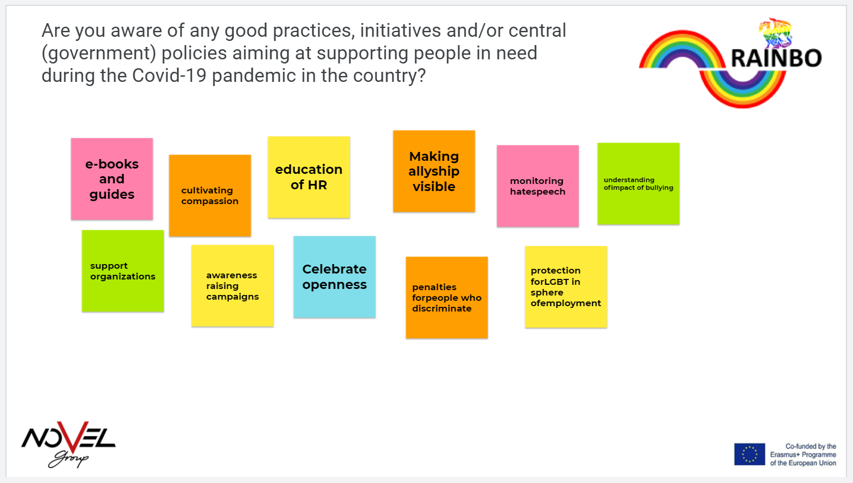

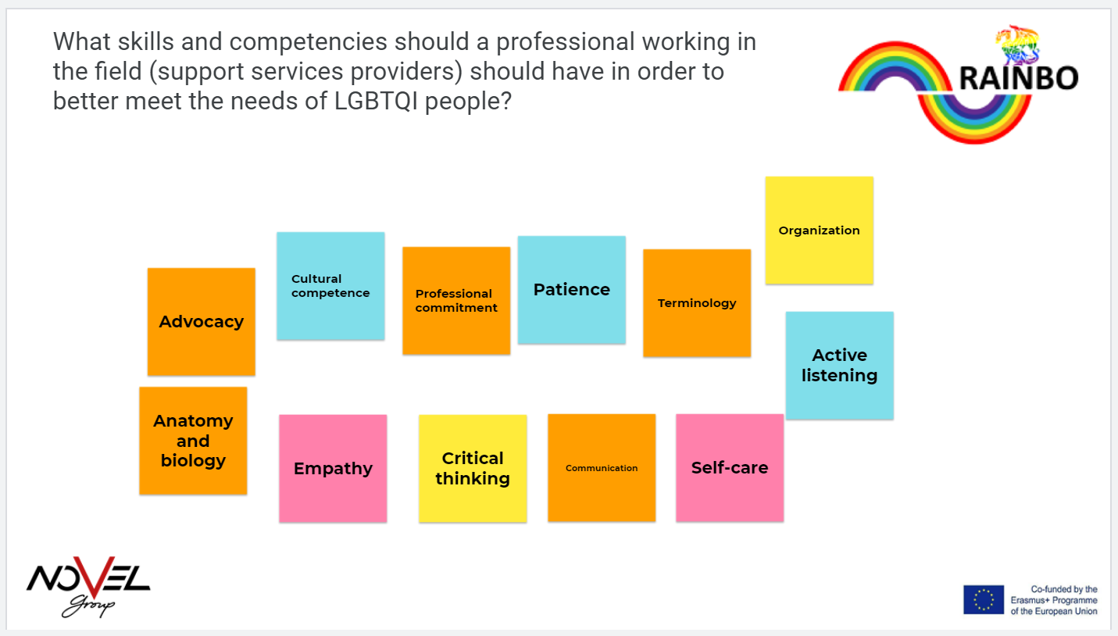
An issue that was raised was health interventions that although have a lot of promise, there is an inefficiency of mental health therapies geared to domestic abuse victims in the COVID-19 environment. Many mental health services and domestic violence support mechanisms have had to postpone or cancel their services, at least face-to-face, as a result of the lockdown and social distancing measures, exacerbating the lack of mental health solutions that many domestic abuse victims suffer. Stay-at-home orders, isolation, heightened stress, and exposure to family members all raise the likelihood of violence, especially among the elderly and children.

Additionally, during the interviews, a concern was raised about claims of selective penalties on the basis of anti-COVID19 measures, with profiling of LGBTQ people being the victims, and a general increase in maltreatment by the authorities. During all interviews with professionals in social services, the issue of negative home environments was raised but mostly for women and transgender minors suffering and going through trauma physically or emotionally. This involves people from all races and genders or ethnicities and has been reported to be both less and more of a problem in families of higher social status or wealth. Persons of higher education, higher family income are more likely to choose who they live with. It makes perfect sense that domestic instances have increased because of often lockdowns, employment insecurities, or psychological insecurities in general, where the victims are exposed to the others more than before. For example, this increase in confinement has been reported to lead to increased exposure to the people of the family who are less accepting (or even abusive), and decreased financial stability; which then led to exacerbated domestic problems. The most commonly found disorders were depression and anxiety.

During the interviews, we gather some useful ideas of interventions that could provide timely and practical solutions to domestic violence victims amid the epidemic. These may be as follows: finding a place to sleep, challenges in education, assistance for mental health using digital technologies and online services. An example of a tactic provided in the interviews was a coded messaging system for abused individuals that will allow them to seek help. Another issue that was raised where the social disparities of LGBTQI people, and the psychological abuse against them. It was mentioned that the pandemic has had a severe impact on LGBTQI people due to socioeconomic instability, inability to escape negative home environments, and augmentation of anxiety and other pre-existing disorders relating to mental and emotional well-being. The perception of poor mental health and increased needs for psychological aid have been observed by all participating services providers.

It is very often that in local contexts LGBTQI people rely on the informal sector for income in numerous situations, especially in the work supply. LGBT people are more likely to work in industries that have been severely affected by the virus and the measures against it, such as food service, retail, hair stylists and fashion, and sex work, rather than people who are legitimately employed or employed in higher ranking occupations.

Another issue that was brought up was the issue of LGBTQI homeless people while it is not one of the biggest problems in Luxembourg. LGBTQI people who are already homeless are in a particularly dangerous situation because their prospects of getting even short-term employment and temporary accommodation have noticeably dropped. Although it was stated that this may not be the case with Luxembourg, it was discussed that LGBTQI people who are homeless had to rely on temporary social accommodation and shelter systems that may be unsafe for marginalized people. In some cases, they must also choose between living in overcrowding temporary housing (which is hazardous) or returning to family and communities that are hostile.

What was also brought up in one of the interviews was the access to medical care and services. People living with AIDS, including LGBTQI people, struggle to get their medication because in many cases such as public hospitals, these also function as COVID-19 hospitals, putting immune-compromised people at risk of being admitted, or deprioritizing the services as non-emergency.

There is a common agreement between all participants that the pandemic's effects are worsened in the case of trans people, particularly in terms of legal gender recognition (lack of official documents that match one's identity and gender expression). Legal gender recognition processes were generally postponed and delayed due to being classified as non-emergency during times when judicial services were limited to those deemed essential during the pandemic.

Receivers
2. Summary analysis of focus groups (and/or interviews) with LGBTQI people (support services receivers) (approx. 1000 words)
Profile of participants (or interviewees), the status of LGBTQI people during the pandemic, good practices, initiatives and available options, needs’ assessment
Participant (or interviewee) | Age | Educational background | Info regarding residence and family/marital status  (e.g., married / living with a partner, living with parents, living alone, living with a roommate etc.)
1 | - | Highschool | Living Alone
2 | 20 | Higher Education Graduate | Living Alone
3 | 20 | Highschool | Living with parents
4 | 29 | Higher Education Graduate | Living Alone
5 | 26 | Highschool | Living Alone
6 | 25 | Highschool | Living with a roommate
7 | 28 | Higher Education Graduate | Living with a roommate
8 | 40 | Vocational education | Living Alone
9 | 45 | Vocational education | Living Alone
10 | 38 | Higher Education Graduate | Living with a roommate

The impact of the epidemic on social exclusion, as well as the connection with drivers of stigma and discrimination, is the focus of the interviews with LGBTQI recipients. We also attempted to identify good practices by analyzing measures taken in the context of the pandemic that were aimed at prosecuting LGBT and gender-diverse people or had indirect or inadvertent discriminatory impacts.
The participants in the study believe that the pandemic has hit the poorest and most vulnerable hardest, and that the measures are showing some serious disparities, as well as insufficient safety schemes, which require immediate consideration. In the study, 5/10 of LGBTQ people said that COVID-19 has caused job loss, income reduction, or reduced hours for someone in their household; 5/10 said they have pandemic-related anxiety and melancholy; and 7/10 said they are worried they are more likely to get sick from COVID19 than their non-LGBTQI friends.

LGBTQ individuals have a long history of prejudice and stigma. It was said that they had greater rates of mental illness and a lack of access to health treatment. We know they have lower salaries and work in industries that are more prone to COVID19, so this is about figuring out how a vulnerable group is affected.

The participants attempted to explain to the moderators the links that exist between stigma, violence, and discrimination, as well as the cycles of exclusion and poverty that many LGBT and gender-diverse people face if they choose to live openly and freely according to their sexual orientation and gender identity. The COVID-19 pandemic seems to have made these situations worse. The epidemic has created difficulties that LGBTQ people already confront, such as employment and housing discrimination, food instability, homelessness vulnerability, inadequate health treatment, and increased rates of mental illness. Though employment losses and economic hardship have been felt across the LGBTQ community, the pandemic has had a particularly negative impact on people who are most vulnerable to discrimination.

The conversations with service recipients have led us to two crucial conclusions: One is that transgender individuals are having a harder time in general, and LGBTQI persons of color are at an even greater disadvantage, which is unsurprising. Prior to the epidemic, many transgender adults lived in poverty or even with their parents at home, which is unusual in countries like Luxembourg. One of the attendees, a black queer woman, stated that black LGBTQI people, particularly trans people, endure the most persecution. After losing their jobs following the spring lockdown of 2020, trans and nonbinary workers must cope with the discrimination that comes with the job application process, which half of the participants have been dealing with since losing their jobs.

In the interviews, a queer white man stated that they have been applying for employment since the winter shutdown of 2020, and that their past work experience includes working in a pub, a retail store, and a supermarket. It is not unusual for them to receive no response to an application, despite the fact that Luxembourg is perceived to be much more receptive than other countries, particularly in urban regions.

A white homosexual woman stated that a human-rights approach to pandemic response is required.
She also highlighted that authorities can employ COVID-19 methods to target or intimidate people based on their sexual orientation or gender identity. She cited instances where authorities used the pandemic to justify stripping people of their right to hold a public gathering, yet it was still allowed in cases where LGBTQI was not present.

The service providers also cited a lack of access to legislators, legal authorities, and advocacy possibilities across the board, and decried a cycle in which LGBT people were unable to meet their basic requirements. Concerns deemed to be LGBTQI issues were not considered a priority at the time, according to a young gay male.

Another issue raised in the interviews was that NGOs and helplines that focus on or aid LGBTQI people rely on donations that have been decreasing over time. Many civil society organizations have seen their funding sources significantly decreased or suspended in a short period of time, while others have warned beneficiaries of budget cuts and diminished resources.

Transitioning to online meeting models, developing effective solidarity networks, enhancing monitoring and reporting systems, and deploying awareness campaigns, all online, has proven to be one of the most beneficial tactics for the LGBTQI civil society.

As a result, we gathered the measures that participants believe are most needed in terms of state and government: participants' feedback concluded that there must always be a political decision to acknowledge and embrace diversity in sexual orientation and gender identity, as well as the adoption of determined measures to deconstruct prejudice/bias/stereotypes. Another need assessment is that governments do not always recognize the existence of LGBTQI stigma and prejudice, resulting in a lack of visibility given to LGBTQI lives in public policy: the government must first acknowledge that their sexual orientation and gender identity are reasons for violence and discrimination, as well as determinants of vulnerability.
A non-native queer young man proposed that NGOs, CSOs, or the government publish instructions on the various economic support programs accessible to LGBT people, such as shelter, health, and emotional support, in the form of a pamphlet or guide.

3. Summary analysis of online research (approx. 1000 words)
Part C: General conclusions – comparative analysis between desk and field research findings (approx. 500 words)

In total only 40 participants answered the questionnaire, 15 were providers and 25 were receivers.
The age groups were as follows: 4 of age 16-19 (10%), 14 of age 20-29 (35%), 16 of 30-39 (40%) and 6 of 40-49 (15%).
The gender identities were 12 Men, 21 women, 2 trans men, 1 trans woman, 5 non binary, and 7 did not want to acknowledge their gender. 15 were straight, 13 were gay/lesbian, 6 were bi, 4 were something else, and 5 did not want to disclose that information. 37.5% were straight, 32.5% were homosexual, 15% something else, 5% did not want to answer.
The majority of the respondents (75%) were of 20 to 39 years old, and this was no accident because we were particularly interested in an already existent problem in the youth: unemployment and mental health challenges.

Experiences of LGBTQI
The first questions asked how they scored on scientific scales for stress and depression. The average score was 8.7. The overall can be up to 16 and over 10 represents a lot of distress. Therefore the Luxembourg LGBTQI are very much distressed with covid19. It should be noted that the results were collected in the heart of the lockdown in 2021 and before the relaxation of the summer.

The other question was the CES-D scale and more than 10 counts as depressed. The Luxembourg scored 14.8 which means depressed. The respondents scored “trouble focusing”, “lonely” and “fearful” more than the other items.
Half of the participants responded that the stress was related to the epidemic, while 67% answered that homophobia and transphobia have remained the same.

Moreover, less than half (42%) of the respondents felt that they were supported during the epidemic, while an alarming 46% answered that they feared physical attacks, 46% felt that they saw people acting uncomfortably around them, and 42% made slurs/jokes.

About half of the respondents sought support service (43%) during covid, the 26% did not, and an alarming 30% does not know.

Regarding the affected services, the most affected areas were, employment 75%, mental health services (75%), and physical health services (75%). Followed by education (46%), career counseling (42%), anti-discrimination support (42%).

Needs of providers:
15 out of 16 providers have provided services to the LGBTQI+ target group during the epidemic. 94% had to offer their services online. 73% found it challenging, and 20% did not.
The 50% of the providers mentioned that they may need different or additional support during the epidemic, compared with non LGBTQI+ people, while 13% disagreed.
We also asked if providers were aware of specific challenges and only 38% mentioned not so well, 38% mentioned not sure and 25% answered well.
To our surprise, the 56% of the providers answered that they received some sort of training on LGBTQI, while 44% said they had not. The two conclusions are in contrast.
Half of the providers answered that they would be interested in a training, while 31% not so much.

The highest scoring needs were:
Challenges for LGBTQI (50%)
Behavioral guidelines (50%)
International good practices (50%)
Key concepts (43%)
Legal framework (43%)
Challenges working remotely (36%)

The lowest scoring needs were:
Support services, Referrals, access for LGBTQI to online services.

REFERENCES
EU LGBTI survey II A long way to go for LGBTI equality. Fra.europa.eu. (2021). Retrieved 13 October 2021, from https://fra.europa.eu/sites/default/files/fra_uploads/lgbti-survey-country-data_luxembourg.pdf.

Over the rainbow. Oecd.org. (2021). Retrieved 13 October 2021, from https://www.oecd.org/luxembourg/OECD-LGBTI-2020-Over-The-Rainbow-LUXEMBOURG.pdf.

Luxembourg Pride Week 2021 and LGBTIQ life. Luxembourg Times. (2021). Retrieved 13 October 2021, from https://www.luxtimes.lu/en/living-in-luxembourg/diversity-luxembourg-pride-week-2021-and-lgbtiq-life-602d6079de135b923695e6dc.

Release of the first best practices guide. IMS Luxembourg. (2021). Retrieved 13 October 2021, from https://imslux.lu/eng/news/337_release-of-the-first-best-practices-guide-lgbti-inclusion-in-the-workplace.

For example, visit https://libguides.murdoch.edu.au/APA/all

